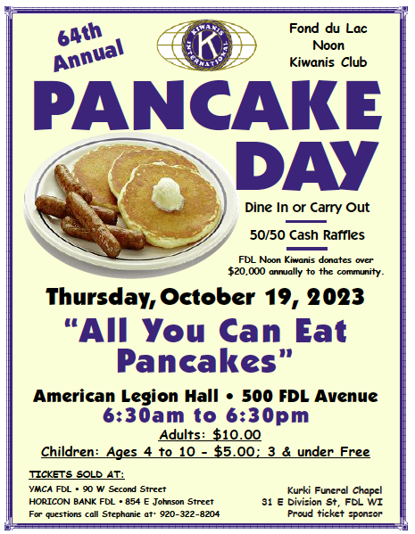
Good afternoon,
Fond du Lac Noon Kiwanis Club is doing their Annual Pancake Day on Thursday, October 19th from 6:30am-6:30pm at the American Legion Hall in Fond du Lac. Enjoy all you can eat pancakes with sausage and applesauce. Adults are $10 and kids are discounted. Tickets are available at the YMCA and Horicon Bank on East Johnson or you can let me know if you want any advanced tickets. Otherwise, you can come without an advanced ticket as well. You can dine in our carry out!

Please contact Stephanie Dahlke with any questions!

